ASSIGNMENT 2

1. Add a 10GB disk to the CentOS.

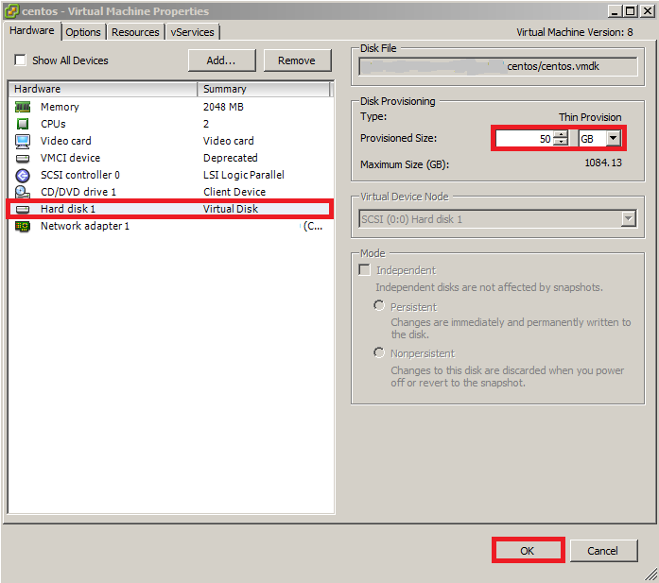

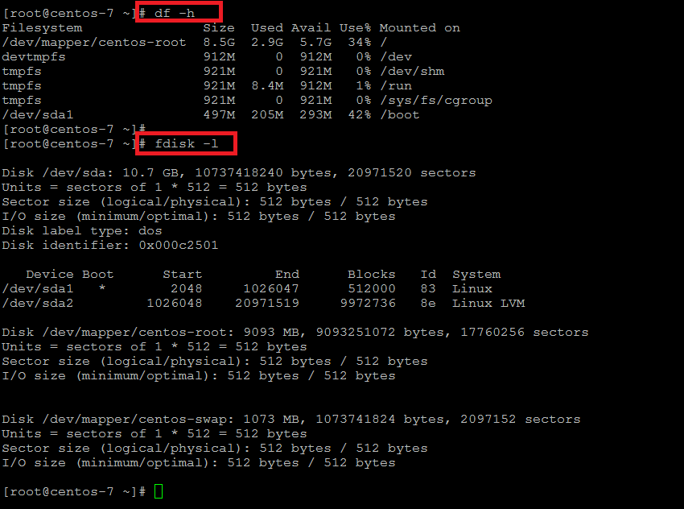

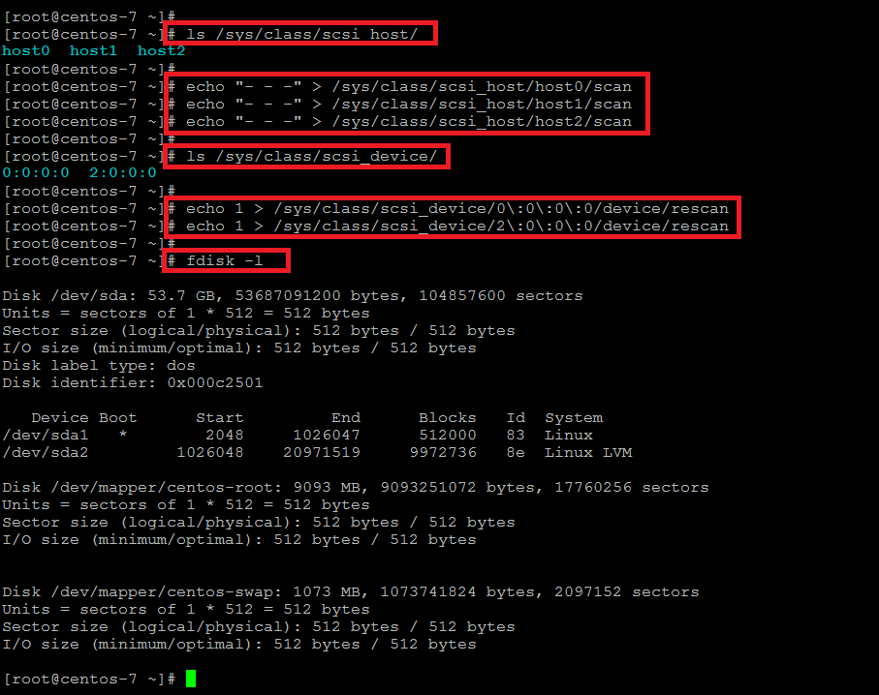

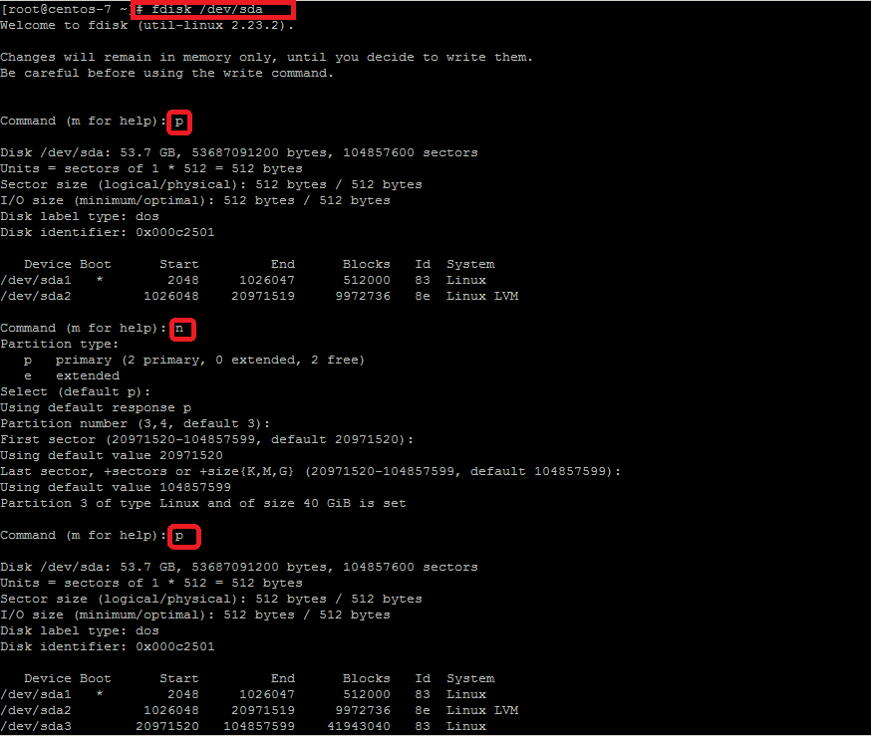

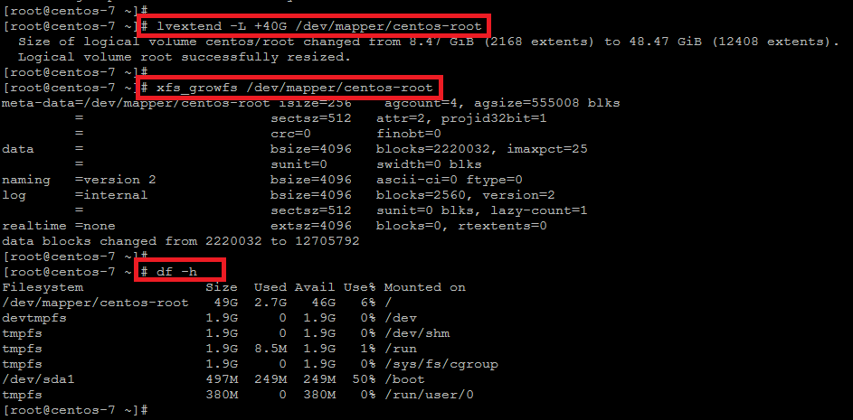

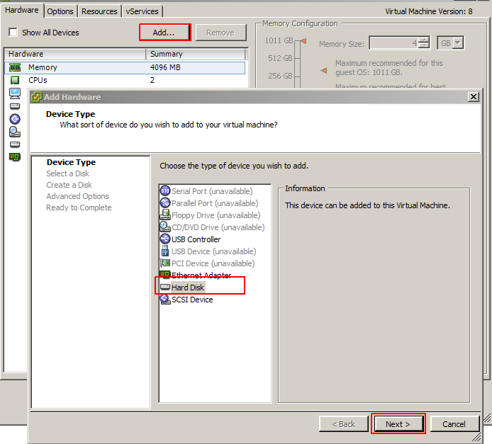

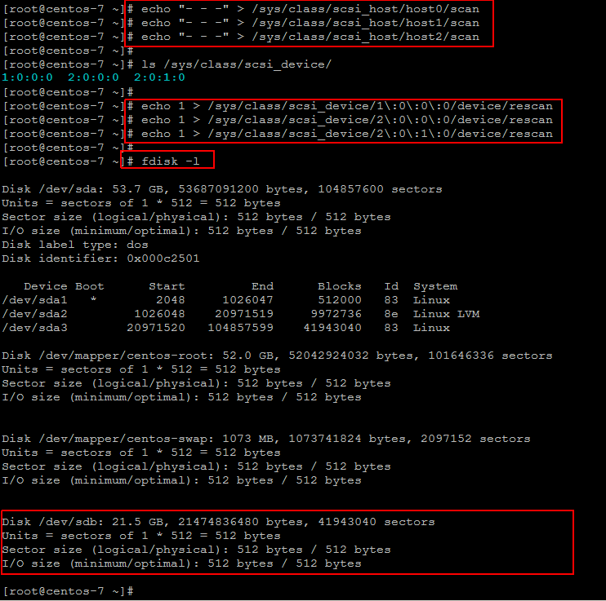 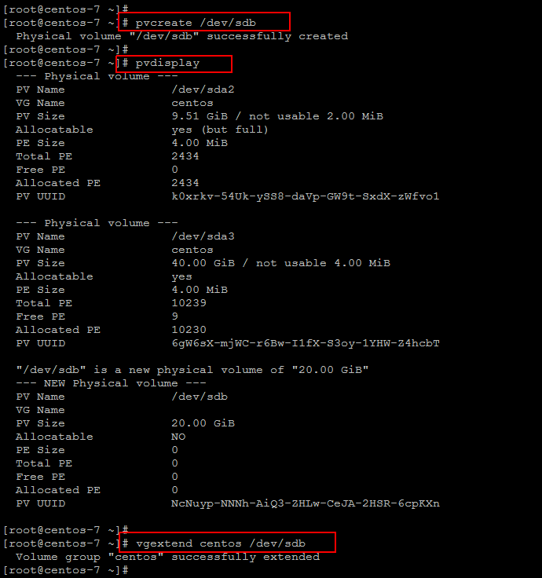

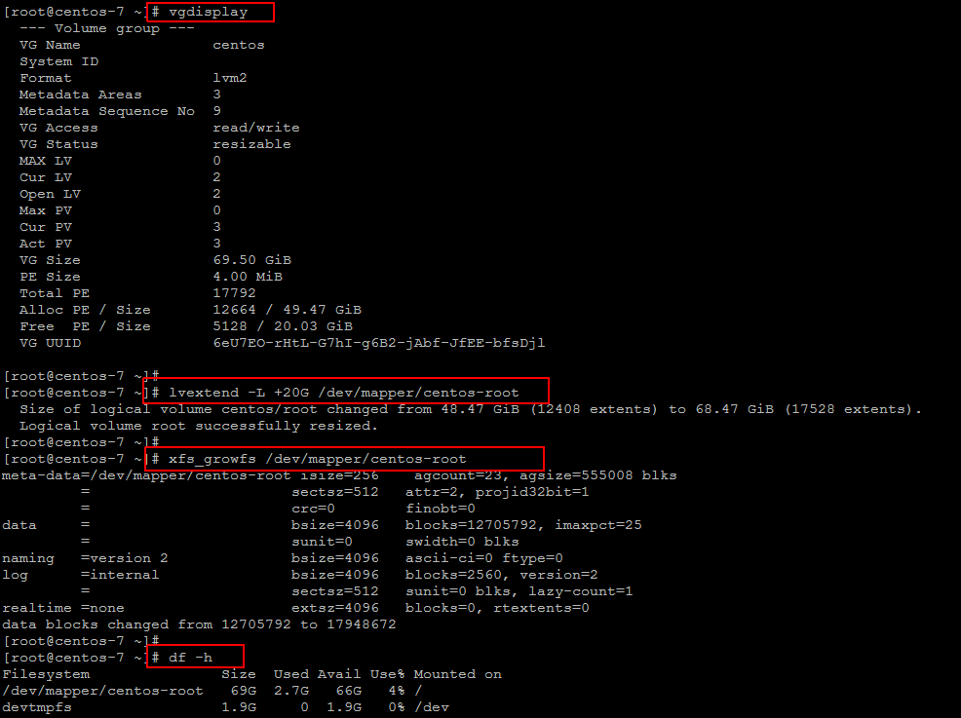

2. Create 2 Partitions 4GB and 6GB of Space respectively

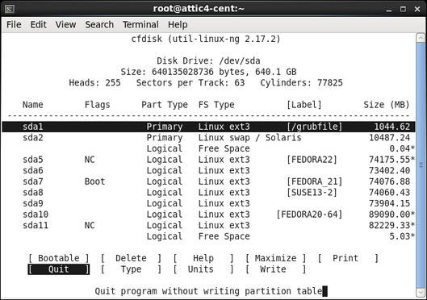

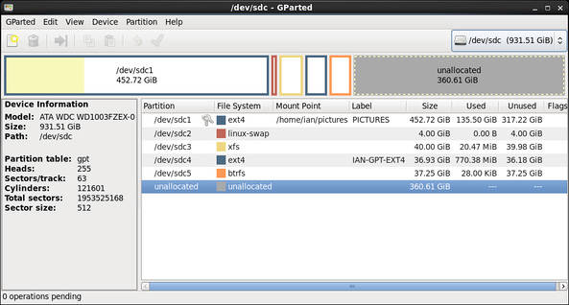

6. Verify the disk Consumption and disk space free in the mounted partitions.

ubuntu:~$ df

Filesystem 1K-blocks Used Available Use% Mounted on

udev 2007152 0 2007152 0% /dev

tmpfs 403960 716 403244 1% /run

/dev/vda1 81120644 31236604 49867656 39% /

tmpfs 2019792 0 2019792 0% /dev/shm

tmpfs 5120 0 5120 0% /run/lock

tmpfs 2019792 0 2019792 0% /sys/fs/cgroup

/dev/vda15 106858 3668 103190 4% /boot/efi

tmpfs 403956 0 403956 0% /run/user/0

tmpfs 403956 0 403956 0% /run/user/1000

$ df -h

Filesystem Size Used Avail Use% Mounted on

udev 2.0G 0 2.0G 0% /dev

tmpfs 395M 716K 394M 1% /run

/dev/vda1 78G 30G 48G 39% /

tmpfs 2.0G 0 2.0G 0% /dev/shm

tmpfs 5.0M 0 5.0M 0% /run/lock

tmpfs 2.0G 0 2.0G 0% /sys/fs/cgroup

/dev/vda15 105M 3.6M 101M 4% /boot/efi

tmpfs 395M 0 395M 0% /run/user/0

tmpfs 395M 0 395M 0% /run/user/1000

$ df -h --output='size','pcent' /

Size Use%

78G 39%

3. Format 4GB with xfs and 6GB with ext4 file system.

~]# mkfs.ext4 /dev/sdb1

mke2fs 1.41.12 (17-May-2010)

Filesystem label=

OS type: Linux

Block size=4096 (log=2)

Fragment size=4096 (log=2)

Stride=0 blocks, Stripe width=0 blocks

245280 inodes, 979456 blocks

48972 blocks (5.00%) reserved for the super user

First data block=0

Maximum filesystem blocks=1006632960

30 block groups

32768 blocks per group, 32768 fragments per group

8176 inodes per group

Superblock backups stored on blocks:

32768, 98304, 163840, 229376, 294912, 819200, 884736

Writing inode tables: done

Creating journal (16384 blocks): done

Writing superblocks and filesystem accounting information: done

This filesystem will be automatically checked every 20 mounts or

180 days, whichever comes first. Use tune2fs -c or -i to override.

# mkfs.ext4 -E stride=16,stripe-width=64 /dev/device